Does Depot- medroxyprogesterone acetate (DMPA) affect Ovary and Uterine tube of White Albino rat? A histopathological study.
Sharma. S¹*, Shakya. T², Koirala. S², Baral.P², Bajrachrya. M¹,
*corresponding author
¹Department of human anatomy, people’s dental college and hospital, Kathmandu, Nepal
²Department of Human anatomy, patan Academy of health sciences, Lalitpur, Nepal
³Department of Human Anatomy, B.P. Koirala Institute of Health Sciences, Dharan, Nepal
Abstract
Even though, progesterone is a hormone naturally produced by ovary, but whether the external progesterone is as beneficial as the natural for female? What alteration occurs due to their prolonged use in different organs of female reproductive tract? We aimed to observe the histopathological changes brought by the long term use of Depot-medroxyprogesterone acetate (DMPA), which is the highly popular and promoted contraceptive in developing countries, in reproductive tract of female rat particularly in ovary and Uterine tube. There were significant changes in the histo-morphology of ovary and uterine tube of experimental group rat compared to the control group. Histological changes such as follicular atresia, medullary hemorrhage and atrophy of uterine tube epithelium was seen in experimental group rat. In conclusion, long- term use of exogenous progesterone, such as DMPA for contraception has adverse impact in Female which outweigh the merits. Instead of promoting these hormonal product, which in long period attenuate the health of female, other non-hormonal methods of contraception should be publicized along with their efficacy.
Key words: atresia, atrophy, hemorrhage, DMPA, follicular.
Introduction:
Unintended pregnancies in low-and middle-income countries remain a serious obstetric problem and awareness and promotion of all types of family planning methods are inevitable in those areas.⁽¹⁾ Family planning has been an important subject for population planners, couples and individuals because it aims for better health and because of its sociocultural benefits.⁽²⁾Depot medroxyprogesterone acetate (DMPA) is one of the most effective reversible contraceptives yet its use is not without side effects which was developed in 1954 as a treatment for endometriosis, and to prevent habitual or threatened abortions.⁽³⁾ In cases where women are at an increased risk of estrogen complications progestin-only hormonal contraception is often prescribed as the method of choice.⁽⁴⁾ The benefit of DMPA relates to the fact that; it is 99% effective at preventing pregnancy when used properly, requires only one injection every 3 months; and offers extended protection due to the crystallized progestin that slowly dissolves into the bloodstream.⁽⁵⁾
Due to these merits it has been used as a contraceptive agent by millions of women in more than 90 countries since 1967 and was approved for use in several developing countries in 1992.⁽⁶⁾ Medroxyprogesterone acetate (17 -acetoxy-6 -methylpregn-4-ene-3,20-dione; MPA) , a synthetic progesterone analog, is used in conception and hormone replacement therapy (HRT) by millions of women worldwide which contraception mechanism is the inhibition of ovulation.⁽⁷⁾
Compared to other progestin-only contraceptives, DMPA contains substantially higher levels of progestin.⁽⁸⁾ A 90-day dosage of DMPA adds up to 150 mg, significantly higher than the 90-day dosages of the progestin- only pill (POP) (31.50 mg), Mirena IUD (1.8 mg), and Implanon/Nexplanon (etonogestrel implant) (6.3 mg).⁽⁹⁾ Consequently, DMPA is associated with more side effects, including irregular menstruation, anxiety, headaches, weakness, fatigue, bloating, abdominal pain, and weight gain.⁽¹⁰⁾ Recent data revealed an increased risk of fracture caused by the DMPA-induced lack of estrogen over extended periods of time, particularly in women who have not yet attained peak bone mass.⁽¹¹⁾ Additionally, many users experience delays in fertility following discontinuation.⁽¹²⁾ DMPA usage is also directly linked to amenorrhea in 70% of users after 2 years.⁽¹³⁾So this study intend to observe the association between the long term use of DMPA and pathological changes in the ovary such as decrease ovarian follicles, follicular atresia and epithelial atrophy in the uterine tube, which may contribute for the delay return of fertility, in DMPA users.

Material and Methods
Sixty healthy female Wistar Albino female rats weighing 150-200 gm were obtained from the animal house of BPKIHS, Dharan. They were given standard pellet diet and drinking water ad libitum. They were maintained in a well ventilated room at controlled ambient temperature (25°c) with a 12 hours in alternating light- dark cycle. They were housed in polypropylene cage (40 cm × 25 cm × 15 cm) with the paddy husk bed, which was changed on every 4-5 days.
Preparation of the Depot-Medroxyprogesterone Acetate Solution
DMPA vials are manufactured by Pfizer pharmaceuticals group. One vial containing 150 mg/ml suspension was diluted in distilled water to make the required concentration for experiment. The experimental groups were given DMPA in the doses of 2.4 mg intramuscularly per week for 8 weeks.
While the control group rats were treated with 0.25 ml of normal saline intramuscularly for 8 weeks. The doses were converted from human dose to rat dose by using multiplication factors for dose conversion between different species by Paget and Barnes as follow.⁽¹⁴⁾
Drug to be given for rat = 0.018 × Human dose

Experimental Design and Treatment Regimen
Animals were divided into 2 groups, with in each group n=15 rats, Total number n= 30
Experimental group rats were sacrificed one day after the completion of 8 weeks. The rats were anesthetized with Ether soaked in cotton. Ovaries and uterine tubes were fixed by In Vivo Perfusion method. After completion of perfusion, the organs were isolated from the body with help of scalpel and forceps and post fixed for 24 hours with Bouin’s Fluid. Thus obtained organs were cut into pieces of 3 mm to fix in neutral buffered formalin for 7 days and processed for making paraffin blocks. The blocks were trimmed, sectioned at 4μm thickness and stained by routine H&E (Hematoxylin and Eosin) staining. All sections were examined under light microscope.
Ethical clearance was taken as per the guideline of Institutional Ethical Review Board (IERB no. 143) of BPKIHS, Dharan, Nepal.
Group | Sample size | Duration of dose
Control | 15 | 8 weeks
Case | 15 | 8 weeks

Result
The microscopic observation was done with the help of light microscope. We compared the appearance of ovarian follicle and medulla in ovary of case and control group. Likewise in uterine tube we compared the appearance of uterine epithelium.
There were remarkable differences in the follicular and medullary appearance of ovary in experimental rat as compared to the normal rat. For instance, in the case group rat’s ovarian follicular atresia as well as the medullary hemorrhage was noticeable compared to the placebo which is shown in photomicrograph 1 and 2 respectively. Similarly, the distinguishable distortion of uterine tube epithelium was seen in case group rats compared to the normal group rats as demonstrated in photomicrograph 3 and 4 respectively.

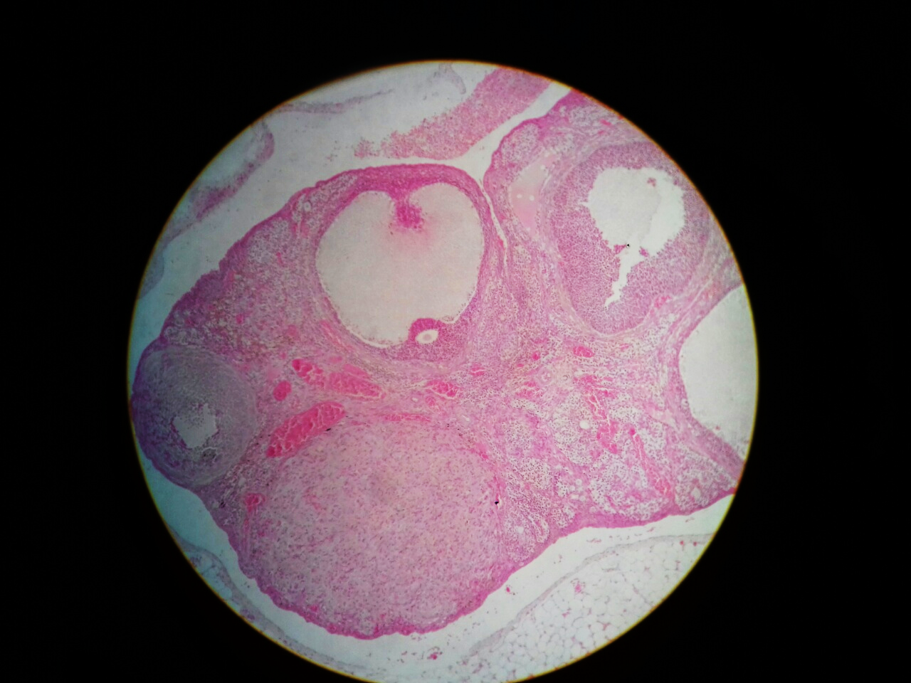Photomicrograph 1: T. S of ovary of case group rat showing the medullary hemorrhage and follicular degeneration (H & E × 10). Green arrow showing hemorrhage. Blue arrow showing follicular atresia and degeneration.
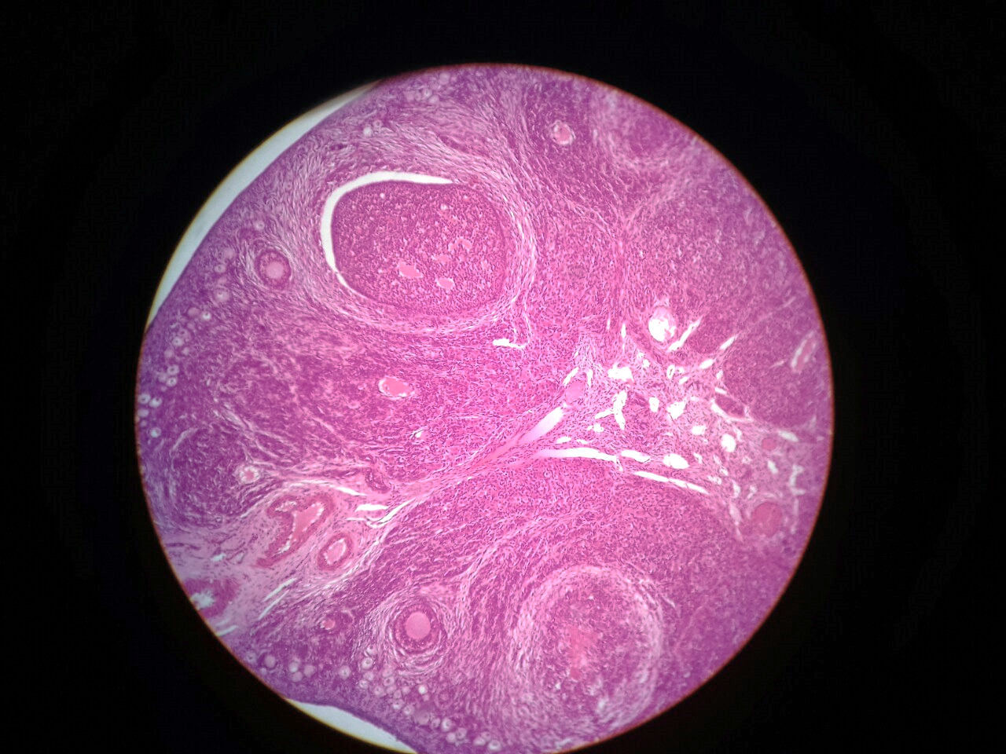
Photomicrograph 2: T. S of ovary of normal group rat ((H & E × 10)

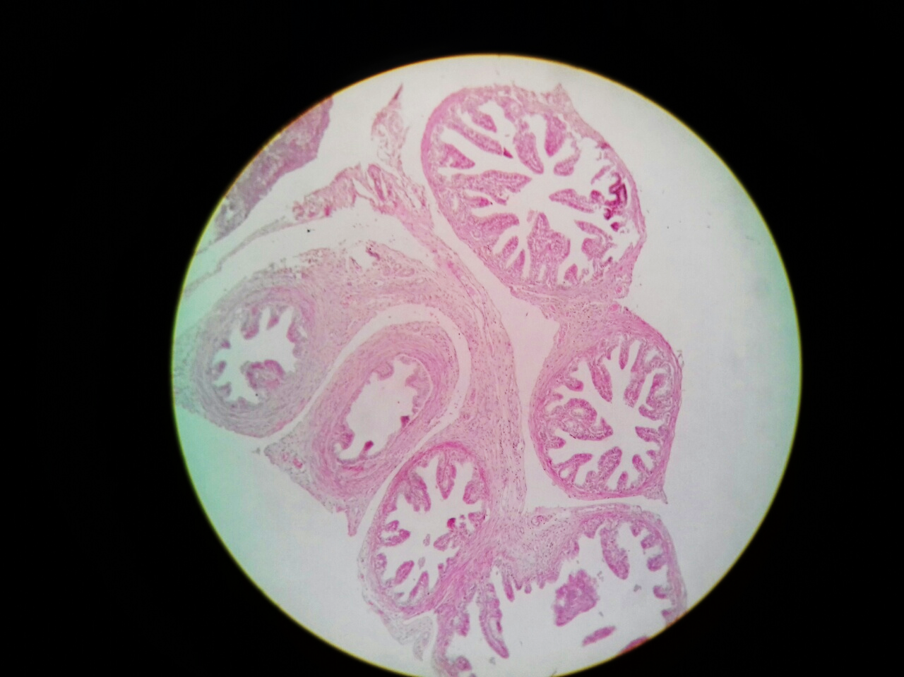
Photomicrograph 3: T. S of uterine tube of case group rat, arrow showing the epithelial atrophy (H & E × 10)

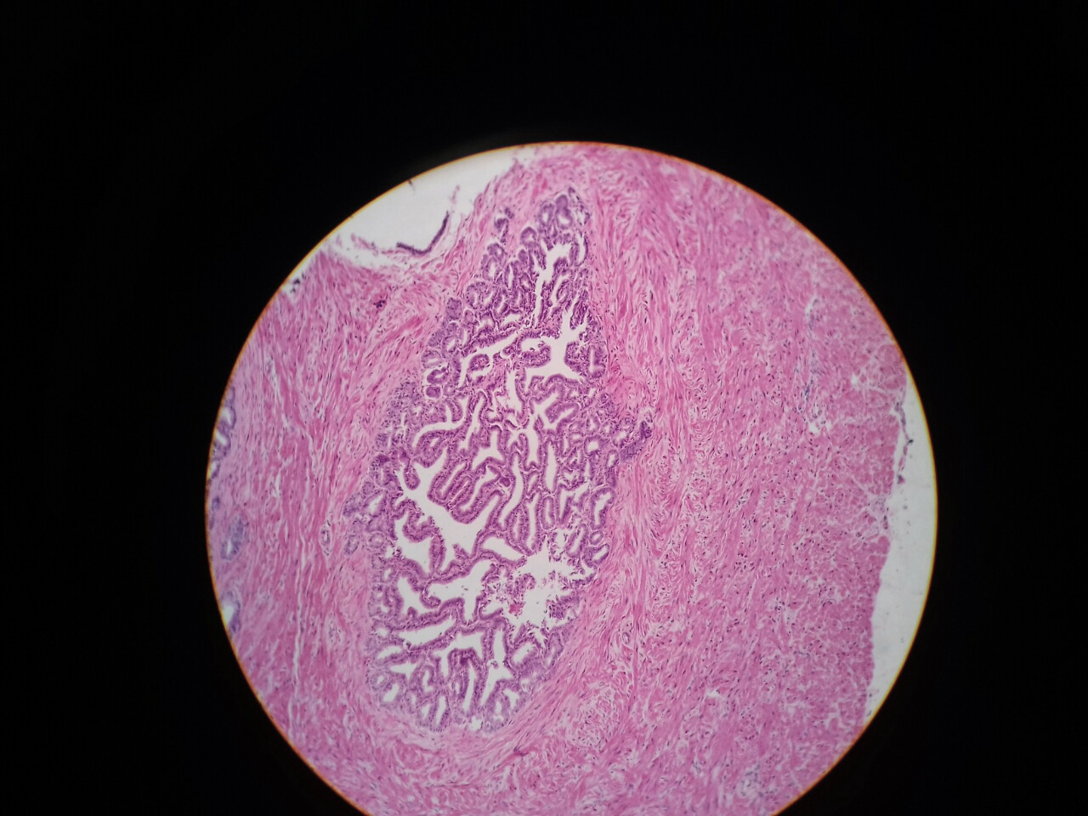
Photomicrograph 4: T. S of uterine tube of normal group rat (H & E × 10)

Discussion
DMPA has been mostly used for contraception by many females without any specific medical supervision particularly in developing countries. With increased popularity, this drug has been also in attention for the peaking osteoporosis, obesity and delayed fertility return problem in the users. Present study found distinguishable distortion in the ovary and uterine tube which might attribute for the delayed fertility return among prolonged user of this contraception.
The medullary hemorrhage and follicular atresia was significant in the ovary of the DMPA treated rat compared to the untreated rat. Similar findings were reported by a study conducted in rats by Bhowmik.T and Mukherjea. M who found the degeneration of ovarian follicle along with follicular atresia in DMPA treated rat which can be due to the apoptotic effect of progesterone on the ovarian follicle. While the hemorrhage can be due to the toxic effect of DMPA. ⁽¹⁵⁾
Another study conducted by Sivakumar. G and Kamakshi. K revealed significant decrease in the number of follicles as well as increased follicular atresia with massive size corpus luteum in DMPA treated rat.⁽¹⁶⁾
In this study, severe atrophy of uterine tube epithelium was observed in the experimental group rat compared to the control group which can be due to the antiestrogenic effects of progesterone in the oviduct where progesterone blocks estradiol-inducible secretory proteins and induces deciliation and cessation of secretory activity of the oviductal epithelium. It can be further aggravated by the disturbance in the cell growth and differentiation due to the effect of steroid hormone.
Another study conducted by Gordon. D et al observed the similar findings, where deciliation and cessation of epithelial growth in the oviduct of progesterone treated Rhesus monkeys was reported.⁽¹⁷⁾
Many other study has found the association of progesterone with the morphological and functional alteration of uterine tube. For example, a study conducted by Hegazy. R and Hegazy. A who also reported the reduced mucosa and ciliary activity of uterine tube in DMPA treated rat.⁽¹⁸⁾
Conclusion
It is believed that DMPA is the most effective contraceptive which has been popular around the world. However, many adverse effect are ensued in the health of DMPA users, such as obesity, loss of bone mineral density, which are considered to be due to the prolong use of the injectable contraceptive. This study also revealed marked alteration in the uterine tube as well as in the ovary of rat which could pose massive impact on fertility of female. To conclude, there is dire need of more rigorous study about the impacts of DMPA in the health of the users as well as promoting the better option for contraception than the hormonal.

Acknowledgement
We would like to express grateful thanks to BP Koirala Institute of Health Sciences, Nepal for providing research facilities and we are also thankful to all staffs, research laboratory and animal house staff for their proper supports during study. We are immensely thankful for the support provided by Patan hospital pathology laboratory staff.

Conflict of Interest
No conflict of interest among the authors.

References
1. Bakry S, Ahmed HA and Al-otaibi ML. Prenatal Exposure to Medroxyprogesterone Acetate. 2010;2(1):1–12.
2. World Health Organization : Facts about once-a-moth injectable contraceptive: memorandum from WHO meeting In: Bulletin of World Health Organization. WHO Offset Publ. 1993;71(6):677–89.
3. Speroff L and Darney PD. Injectable contraception. A Clinical Guide for Contraception. 4th ed. Philadelphia, PA: Lippincott Williams & Wilkins; 2005:201–220. In.
4. Hatcher R. Depo-Provera injections, implants, and progestin-only pills (minipills). In Hatcher RA, Trussell JS, Felicia H, et al. Contraceptive Technology. 18th rev. ed. New York, NY: Ardent Media; 2004:461–494. In.
5. Spevack E. The Long-term Health Implications of Depo-Provera. 2013;12(1):27–34.
6. Zhang J et al. Metabolic Profiling and Cytochrome P450 Reaction Phenotyping of Medroxyprogesterone Accetate. J. of drug metabolism and disposition 2008;36(11):2292–8.
7. Ratchanon and Taneepanichskul. Depot medroxyprogesterone acetate and basal serum prolactin levels in lactating women. Obstet Gynecol. 2014;96(6):926–8.
8. Pfizer. Depo-Provera Contraceptive Injection, US patient labeling. Available from: http:// www.pfizer.com/pfizer/download/ppi_depo_provera_contraceptive.pdf.
9. Mosher WD et al. Use of contraception and use of family planning services in the United States. Adv Data. 2004;350:1–36.
10. Stacey D. Depo Provera: The birth control shot.Available from http://contraception.about. com/od/prescriptionoptions/a/depoprovera.htm. Updated August 26, 2010. Accessed January 12, 2011.
11. Walsh JS, Eastell R and Peel NF. Effects of Depot medroxyprogesterone acetate on bone density and bone metabolism before and after peak bone mass: a case-control study. J Clin Endocrinol Metab. 2008;93(4):1317-23.
12. Tolaymat L and Kaunitz A. Use of hormonal contraception in adolescents: skeletal health issues. Curr Opin Obstet Gynecol. 2009;21(5):396-401.
13. Meier C et. al. Use of depot medroxyprogesterone acetate and fracture risk. J Clin Endocrinol Metab. 2010;95(11):16–4909.
14. Paget G and Barnes J. Interspecies dosage conversion schem in evaluation of results and quantitative application in different species. In: Laurence D, Bacharach A, editors. Evaluation of drug activities: Pharmacometrics. London and New York: Acamemic Press; 1964. p. 160–2.
15. Bhowmik T and Mukherjea M.“Histological changes in the ovary and uterus of rat after injectable contraceptive therapy”. Contraception. 1988;37(5):529–538.
16. Sivakumar G and KamakshiK. Study of oestrous cycle and histomotphometry of ovary in DMPA and a polyherbal drug trated adult female albino rats. Int J Curr Res Rev. 2012;4(5).
17. Niswender GD et al. Mechanisms controlling the function and life span of the corpus luteum. Physiol Rev. 2000;80:1–29.
18. Hegazy R and Hegazy A. DMPA- Induced Changes in Estrogen and Progesterone Receptors of Ampulla of Rat-oviducts: An Immunohistochemical Study). Univers J Med Sci. 2015;3(2):33–40.

